Richard Schall

CS-499-T4206: Computer Science Capstone

Southern New Hampshire University

March 28, 2021

**4-2 Milestone Three: Enhancement Two: Algorithms and Data Structure**

1. **Artifact Description**

The artifact chosen for all the enhancements and my ePortfolio is the Weather Station application. This application was developed in CS 350 – Emerging Systems and Architecture. This application was developed January through the end of February 2021.

The application has two parts there is the backend software written in Python that is ran on a Raspberry Pi 3 unit. The raspberry Pi is an embedded Linux device running the Raspbian distribution of Linux. The second part is a dashboard application that runs on the web browser of a client PC. The dashboard uses JavaScript and graphs provided by CanvasJS.

1. **Artifact Justification**

I chose the Weather Station application because it encompasses almost all aspects of my education at SNHU. Through enhancements, I can thoroughly demonstrate all the skills I have acquired. Specifically, the demonstration of algorithms and data structures in the Weather Station Python code, through enhancements, shows my ability to create algorithms and use data structures. The algorithms created through enhancements are an algorithm for converting Celsius to Fahrenheit, and algorithms for finding the minimum, maximum, and average temperature, and humidity. The data structure used is the Python list to store temperature and humidity data that is used to compute averages for temperature and humidity.

**Algorithm for Converting Celsius to Fahrenheit:**

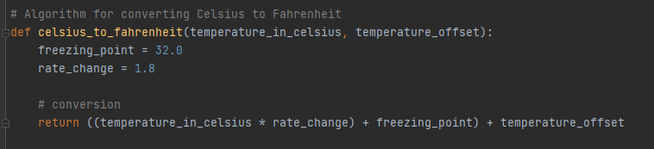

**Algorithm for Finding Temperature Minimum, Maximum, and Average:**

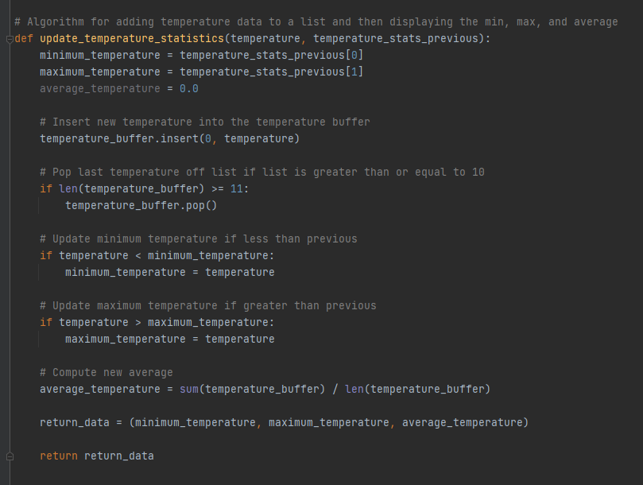

**Algorithm for Finding Humidity Minimum, Maximum, and Average:**

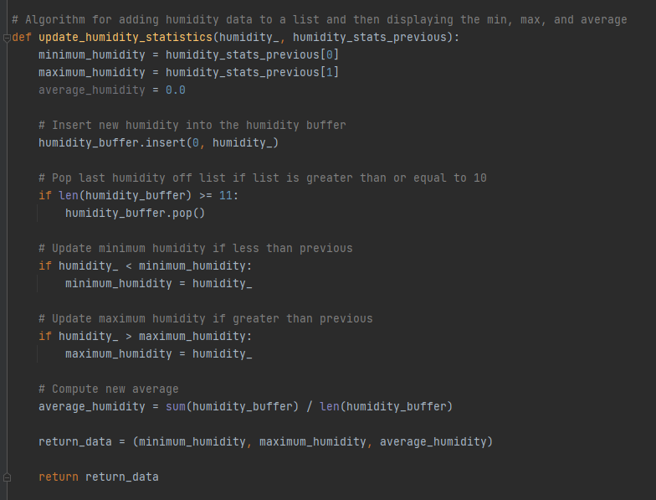

**Data Structure (Python List) for Storing Temperature Data:**

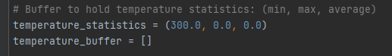

**Data Structure (Python List) for Storing Humidity Data:**

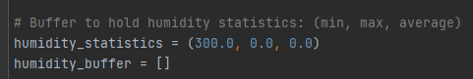

**Shell Output of Weather Station Showing Enhancements:**

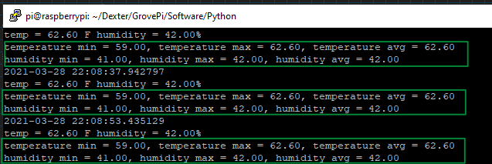

1. **Objectives**

I feel I have met the objectives with the enhancements to this artifact. I demonstrated the use of algorithms to encapsulate functionality. I used a simple data structure to store temperature and humidity data. I could have used a more complicated data structure like a binary tree, but a simple list was adequate for my needs.

**Reflection**

My initial plan did not adequately demonstrate algorithms and data structures. I was initially going to develop an algorithm that would attempt to predict future weather based off historical data. I do not have the amount of data needed to appropriately develop a model for doing this. My enhancements in this Milestone keep me on track with the objectives of this course which is a professional ePortfolio.